**Output File:**

Endpoint: /jobs

Method: GET

Response:

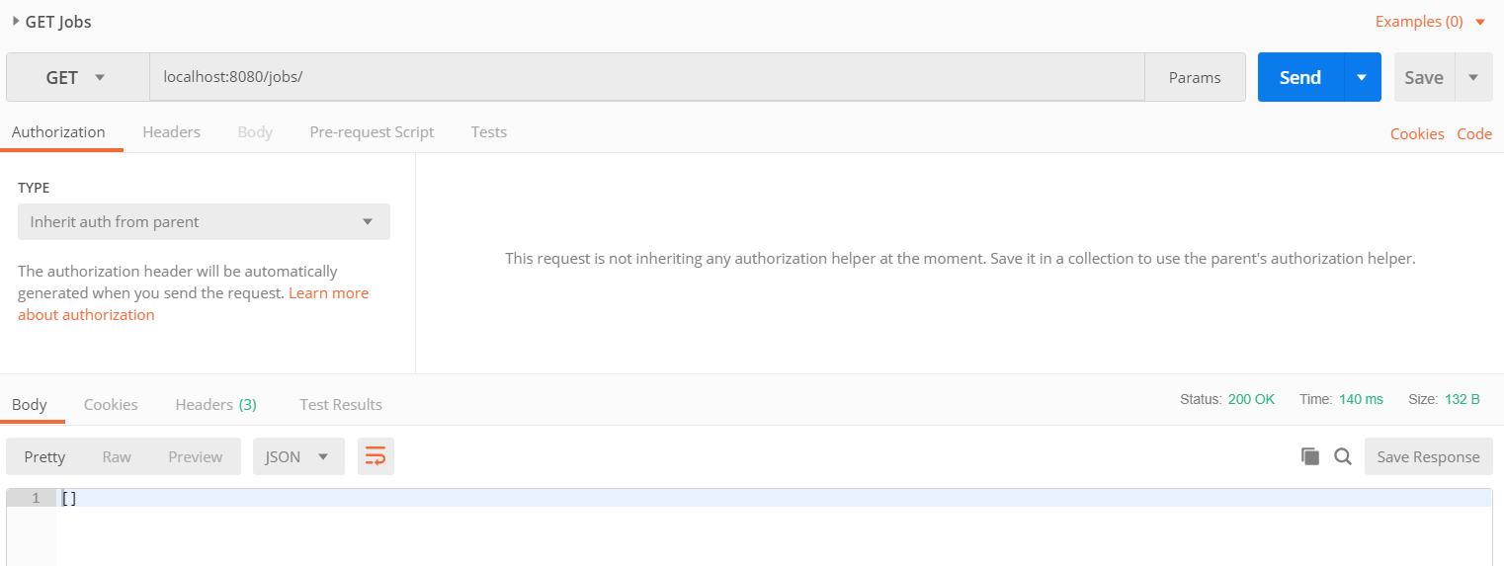

Endpoint: /jobs

Method: POST

Response:

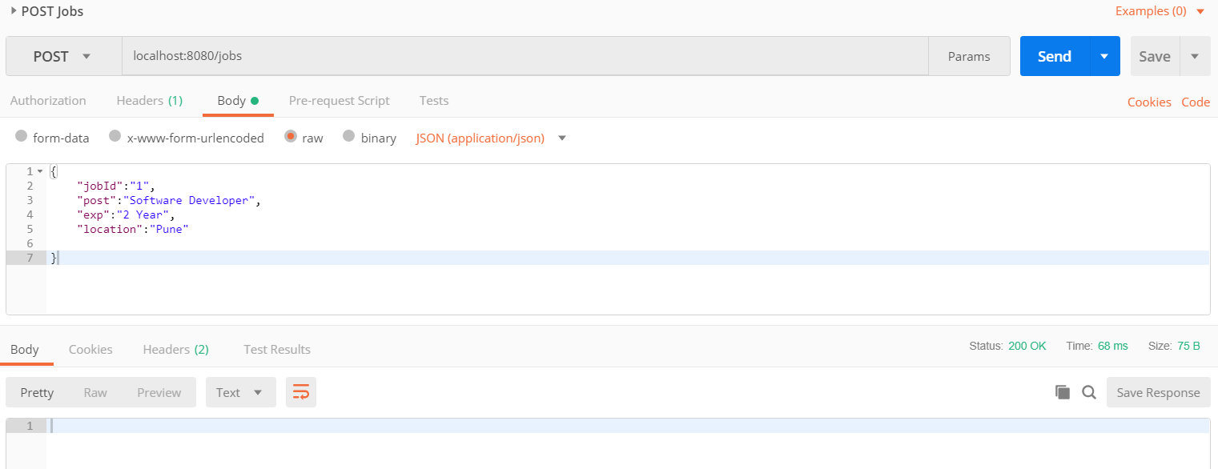

Endpoint: /jobs

Method: GET

Response:

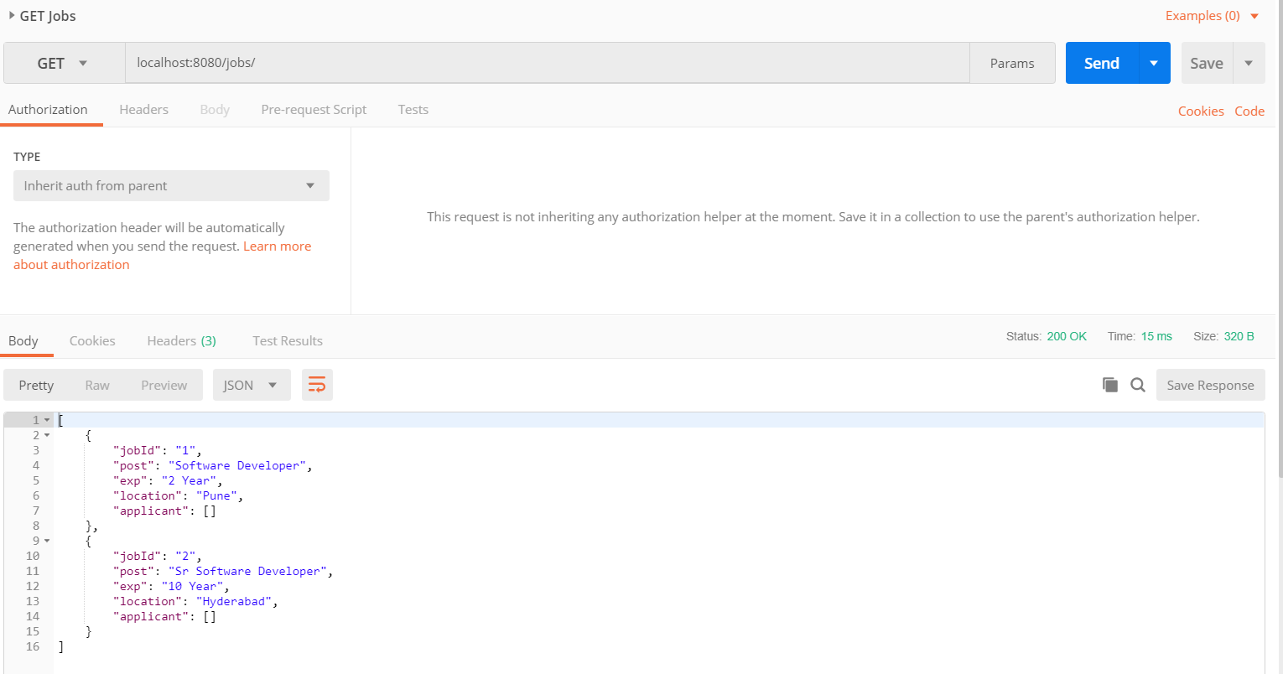

Endpoint: jobs/{jobId}/

Method: PUT

Response:

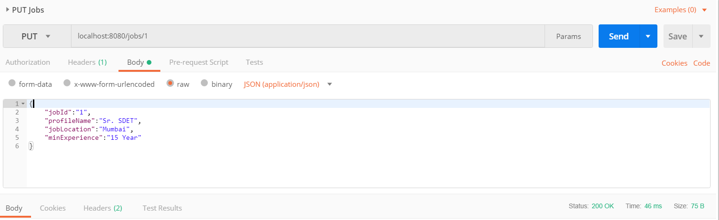

Endpoint: /jobs

Method: GET

Response:

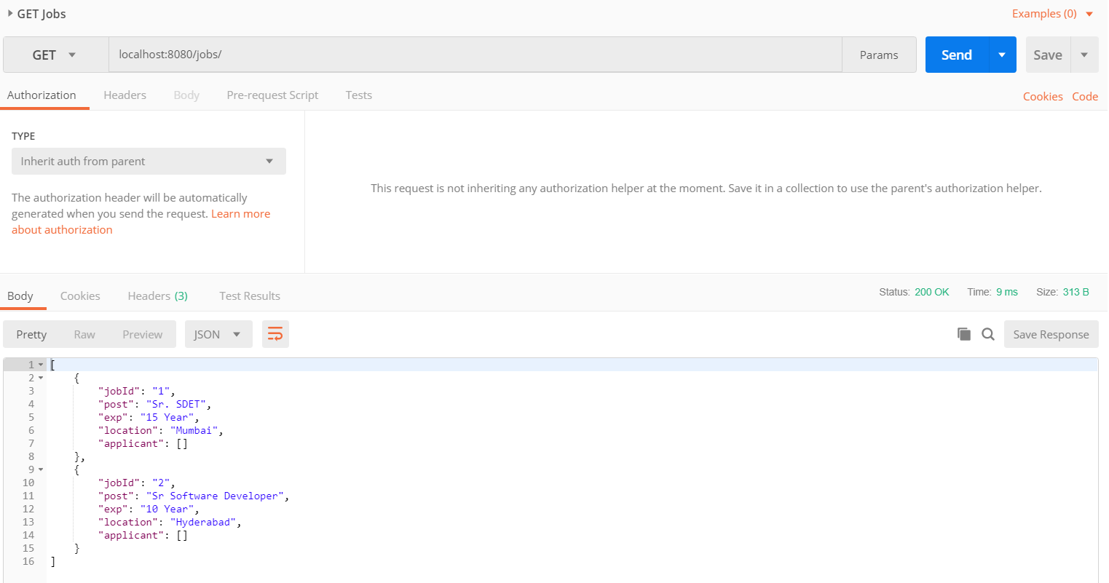

Endpoint: jobs/{jobId}/

Method: DELETE

Response:

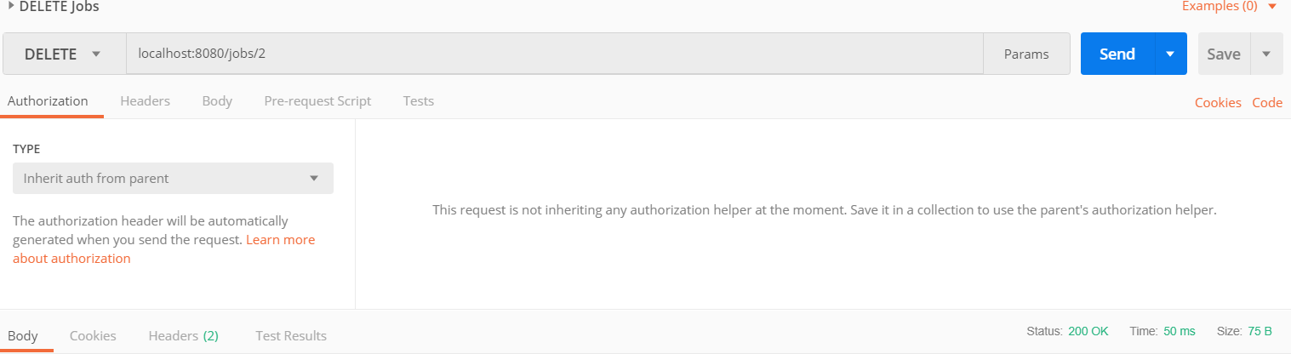

Endpoint: /jobs

Method: GET

Response:

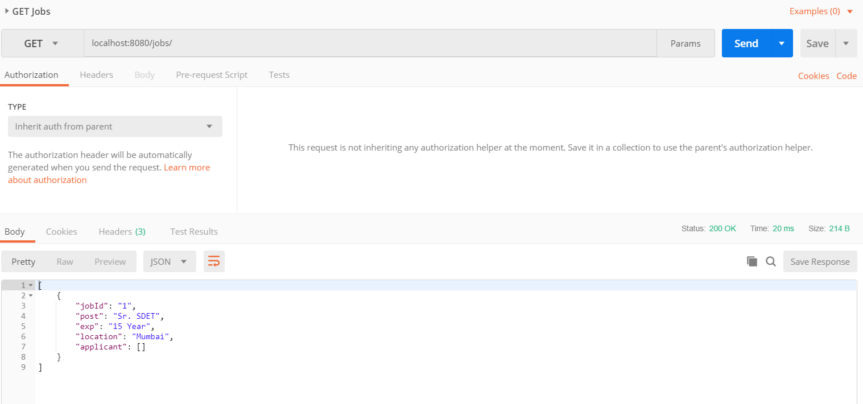

Endpoint: jobs/{jobId}/apply

Method: GET

Response:

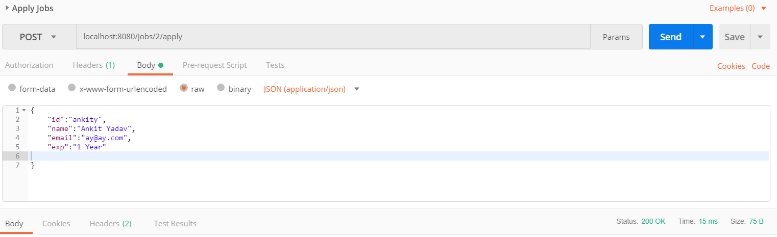

Endpoint: /jobs

Method: GET

Response:

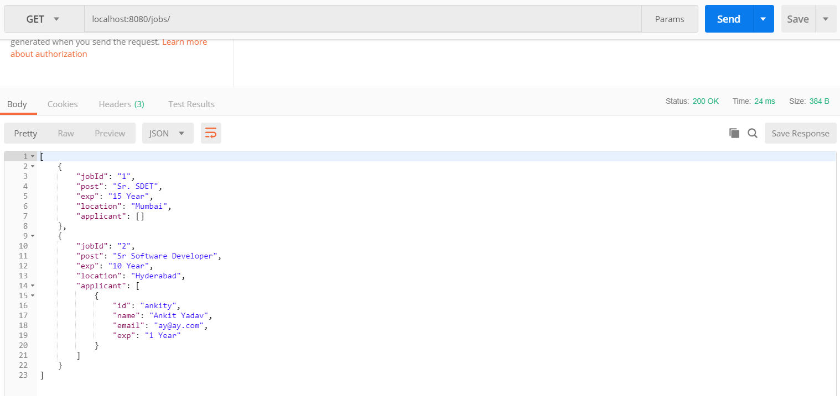

Endpoint: jobs/{jobId}/applications/{id}

Method: PUT

Response:

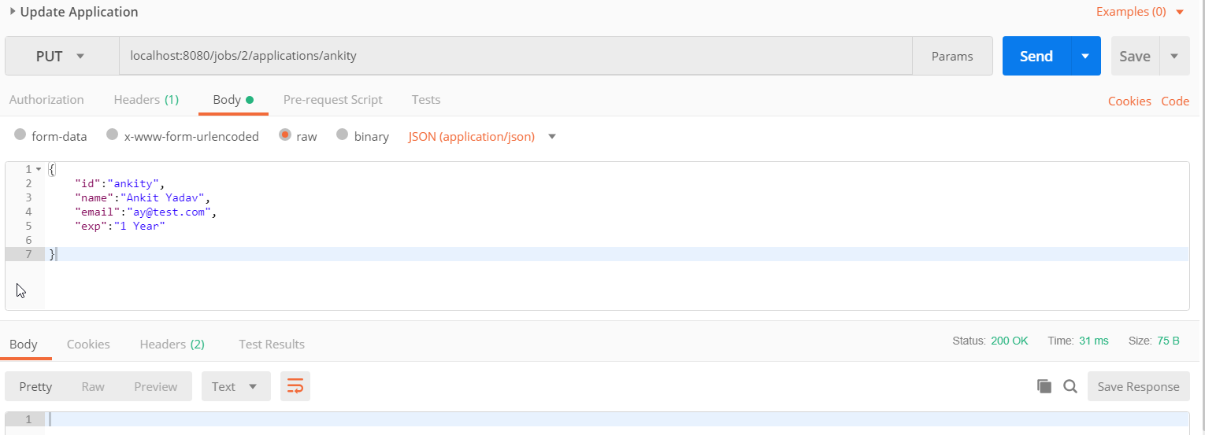

Endpoint: jobs/{jobId}/applications/{id}

Method: GET

Response:

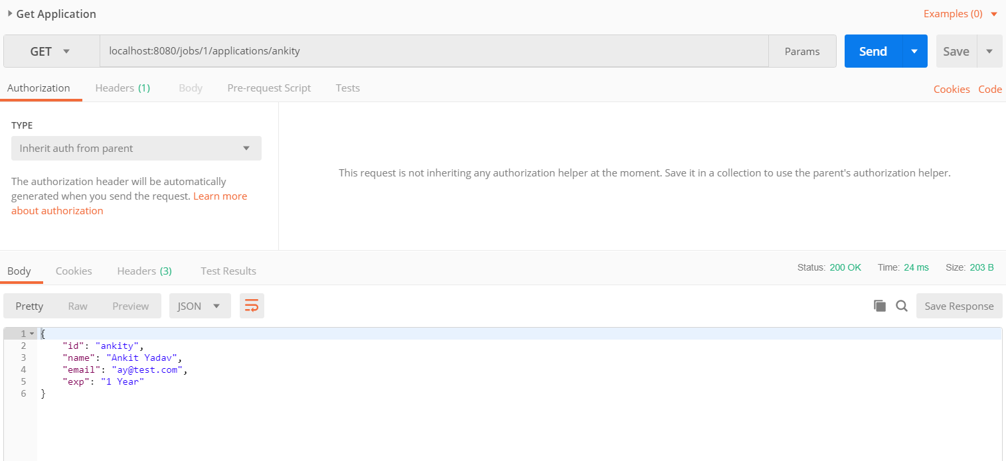

Endpoint: jobs/{jobId}/applications/{id}

Method: DELETE

Response:

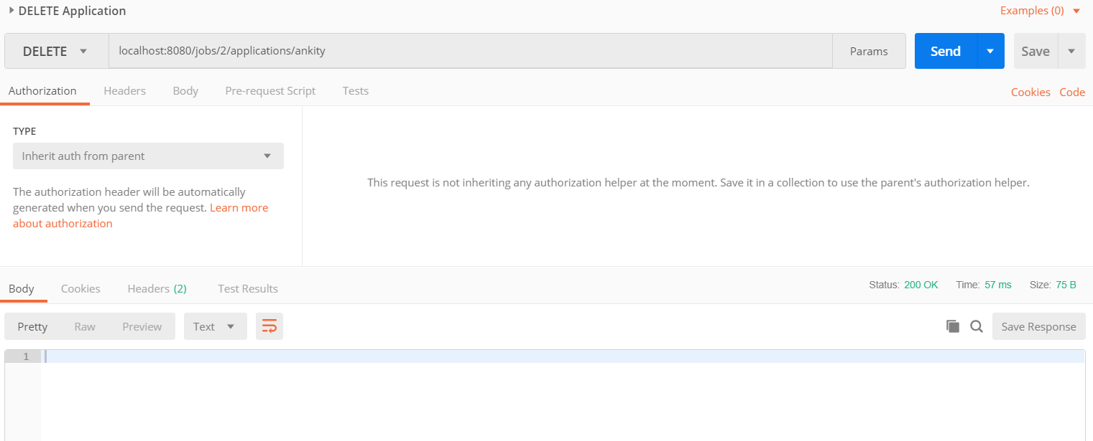

Endpoint: /jobs

Method: GET

Response:

